P A R T I C U L A R S O F S T A F F

Name and address of the Institution: MODERN COLLEGE OF EDUCATION, BIR KALAN (SANGRUR) Course: (D.El.Ed.) Session: 2022-23
S. N. | Name with Date of Birth  Age | Attested photograph of the appointed staff | Whether SC/ST/OBC/other Category |  |  | Designation |  | B.Ed. Yes/No |  |  | M.Ed. Yes/No | M.A (Education) Yes/No |  | Master’s Degree in school subject Yes/No |  |  |  | Subject of Teaching | Ph. D. (Education/ Specify the subject) Yes/No |  | Passed UGC NET or equivalent Yes/No |  | Teaching Experience in Years | Teaching Experience in Recognized School/BEd. College (Enclose experience certificate from the Principal) | Date of initial appointment and NCTE Regulation under which he or she was appointed | Joining Date
 |  |  |  |  |  |  |  | If yes, %age of Marks |  |  | If yes, %age of Marks | If yes, %age of Marks |  | If yes, %age of Marks & specify the subject
(1) | (2) | (3) | (4) |  |  | (5) |  | (6) |  |  | (7) | (8) |  | (9) |  |  |  | (10) | (11) |  | (12) |  | (13) | (14) | (15) | (16)
I. | DETAILS OF TEACHING STAFF
I (A) | HOD
I | DR. D.K. DWIVEDI  31.01.1962  59 YRS. | 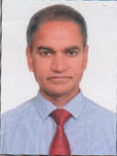 |  | GENERAL |  |  | ASSOCIATE PROFESSOR/H.O.D. | YES  57.5% |  | YES  62% |  |  | -------- |  | M.A. HISTOR 50.2% |  |  | EDUCATION |  | YES |  | ----- | 21 YEARS | 21 YEARS  COLL. | 01/09/2019 |  | 01/09/2019
II | LECTURES/TEACHING STAFF (AS PER NCTE NORMS)
2. | RAJNI RANI  20.03.1984  37 YRS. |  |  |  | GENERAL |  | LECTURER | YES  73% | ----- |  |  |  | YES 54% |  |  | M.A. HINDI 53.62% M.A. HISTORY 55.37% | TEACHING OF HISTORY |  |  | NO |  | NO | 5 YEARS | 5  YEARS COLL. | 01/08/2016 |  | 01/08/2016
3. | SANTOSH SHARMA  12.10.1985  36 YRS | 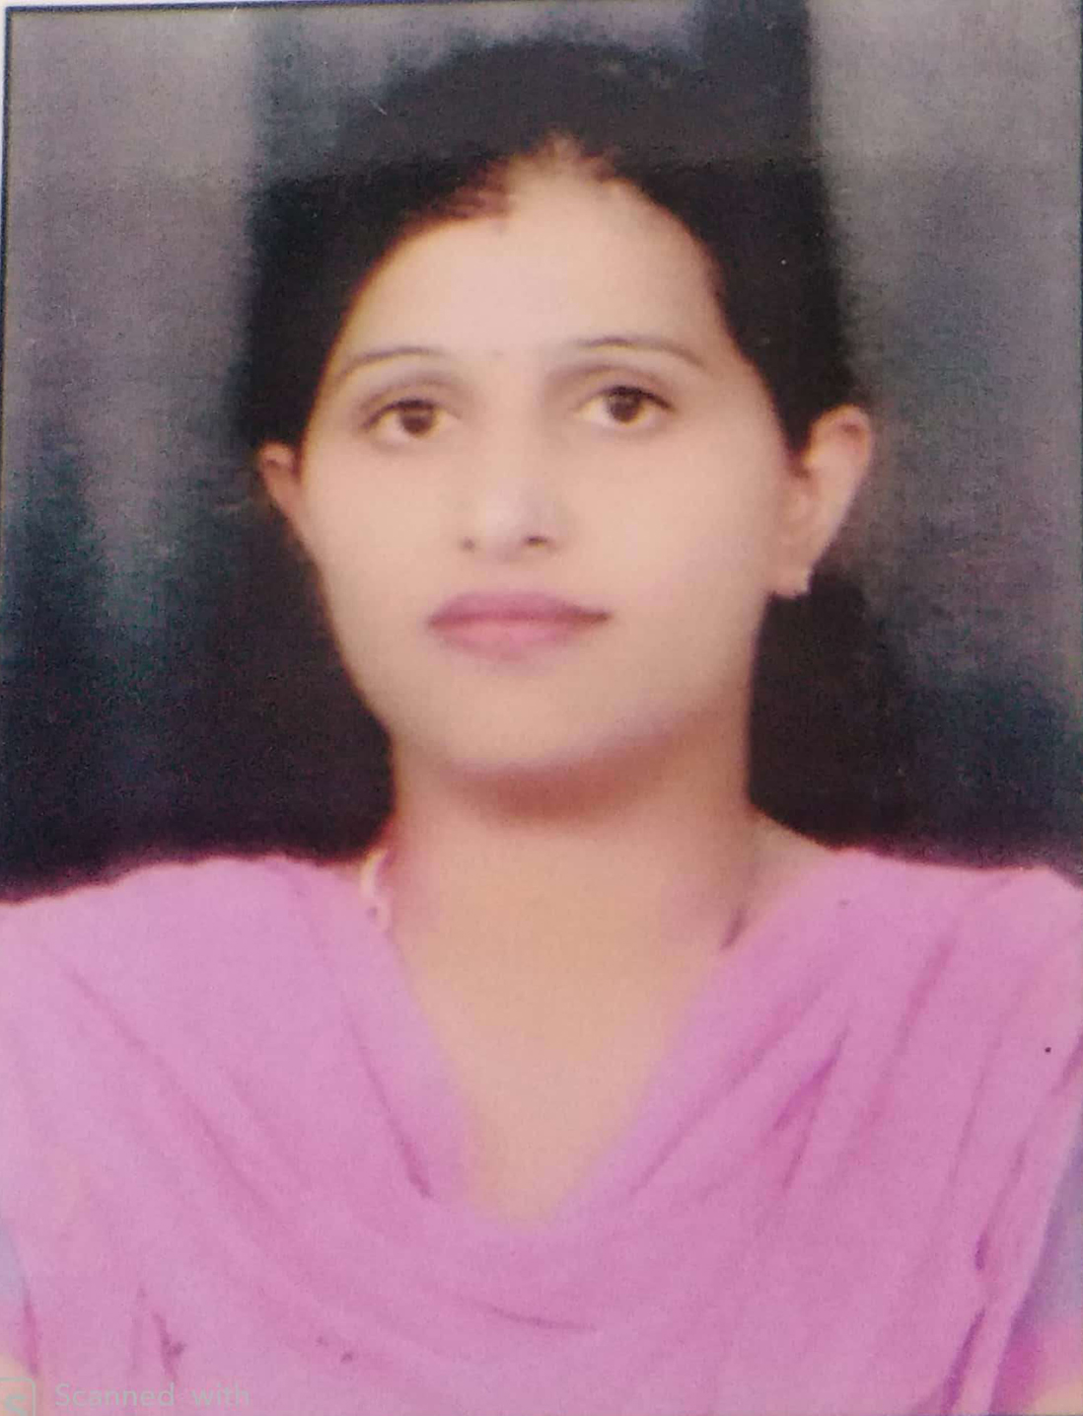 |  |  | GENERAL |  | LECTURER | YES 74% | YES  52% |  |  |  | ------ |  |  | M.A. HINDI 58% | TEACHING OF HINDI |  |  | NO |  | NO | 2 YEARS | 2 YEARS  COLL | 05/09/2019 |  | 05/09/2019
4. | GURSEWAK SINGH 10.03.1983  34 YRS | 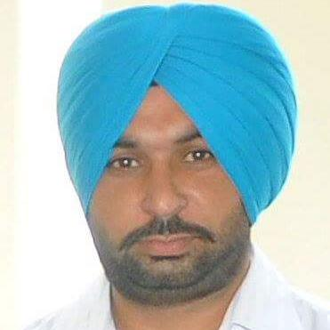 |  |  | GENERAL |  | LECTURER | YES 74.41% | NO |  |  |  | YES |  |  | M.A. PUNJABI 61% | TEACHING OF EDUCATION |  |  | NO |  | YES | 2 YEARS | 2  YEARS  COLL. | 01/09/2019 |  | 01/09/2019
5. | GURPREET KAUR  29/06/1990  31 YRS. |  |  |  | GENERAL |  | LECTURER | YES 52% | YES  88% |  |  |  | ---- |  |  | M.A. HISTORY 77% | TEACHING OF HISTORY |  |  | NO |  | YES | 1 YEAR | 1 YEAR | 01/10/2021 |  | 01/10/2021
6. | RUPINDER KAUR  20.09.1992  29 YRS | 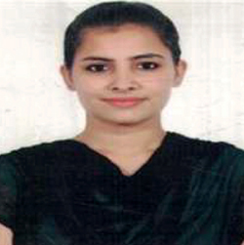 |  |  | GENERAL |  | LECTURER | YES  73% | YES |  |  |  | --- |  |  | M.A  ENGLISH  52% | TEACHING OF ENGLISH |  |  | NO |  | NO | 1 YEAR | 1 YEAR | 01/01/2022 |  | 01/01/2022

