P A R T I C U L A R S O FS T A F F

Name and address of the Institution:MODERN COLLEGE OF EDUCATION, BIR KALAN (SANGRUR) Course:Bachelor of Education (B.Ed.) Session: 2022-23
Sl. No. | Name with Date of Birth  Age | Attested photograph of the appointed staff |  | Whether SC/ST/OBC/other Category |  | Designation | B.Ed. Yes/No |  |  | M.Ed. Yes/No | M.A (Education) Yes/No |  | Master’s Degree in school subject Yes/No |  | Subject of Teaching |  | Ph. D. (Education/ Specify the subject) Yes/No | Passed UGC NET or equivalent Yes/No | Teaching Experience in Years | Teaching Experience in Recognized School/BEd. College (Enclose experience certificate from the Principal) |  | Date of initial appointment and NCTE Regulation under which he or she was appointed |  | Joining Date
 |  |  |  |  |  |  | If yes, %age of Marks |  |  | If yes, %age of Marks | If yes, %age of Marks |  | If yes, %age of Marks & specify the subject
(1) | (2) | (3) |  | (4) |  | (5) | (6) |  |  | (7) | (8) |  | (9) |  | (10) |  | (11) | (12) | (13) | (14) |  | (15) |  | (16)
I. | DETAILS OF TEACHING STAFF
I(A) | PRINCIPAL/HOD
I | DR. V.K. RAI  5.1.1958  62YRS  vk_rai58@yahoo.co.in | 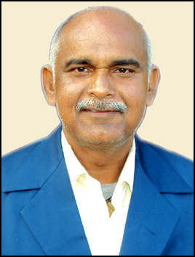 |  |  | GEN. | PRINCIPAL |  | YES  Theory 58.6%  Practical 60%  Special Paper  64.67% | YES  63.33% |  |  | ------ |  | M.A.  SOCIOLOGY  55.11% |  | ----------- | YES | NO | 27 YEAR | B.ED. COLLEGE  27 YEAR | 05/05/07 |  |  | 05/05/07
II | LECTURES/TEACHING STAFF (AS PER NCTE NORMS)
 | NAVITA GUPTA  11.10.1970  50 YR.  navitagupta@gmail.com |  | 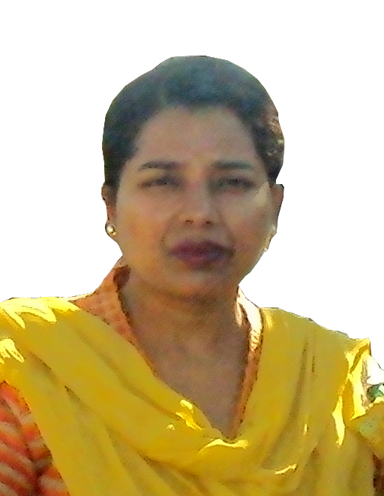 |  | GEN. | ASSISTANT PROFESSOR |  | YES  66% | YES  61% |  |  | ------- |  | M.A.  Economics 55%  Hindi 60% |  | TEACHING OF SOCIAL STUDIES | NO | YES | 14 YEAR | B.ED COLLEGE 14 YEAR | 25/08/05 |  | 25/08/05
 | ANIMA  1.8.1969  51 YR.  anima.ldh42@yahoo.com |  | 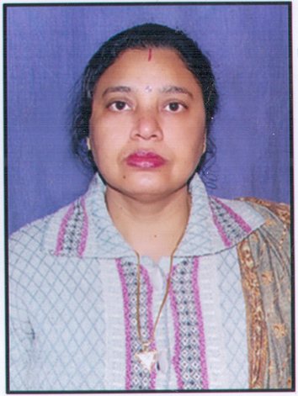 |  | GEN. | ASSISTANT PROFESSOR |  | YES  58.6% | YES  55% |  |  | -------- |  | M.A.  Hindi 60%  M.Phill ( Hindi) |  | TEACHING OF HINDI | NO | No | 20 MONTH | B.E D COLLEGE  20 YEAR | 09/11/06 |  | 09/11/06
 | HARPREET KAUR  25.12.1979  41 YR.  harseerat79@gmail.com |  | 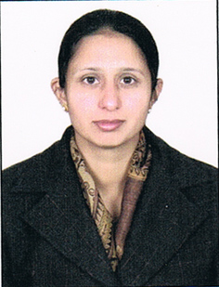 |  | GEN. | ASSISTANT PROFESSOR |  | YES  58% | YES  57% |  |  | -------- |  | M.A. PUNJABI 52%  M.A. HISTORY  56.37 %  M.PHILL(EDU.) |  | TEACHING OF PUNJABI | NO | NO | 13 YEAR | B.ED. COLL.  13 YEAR | 20/02/09 |  | 20/02/09
 | AMANDEEP KAUR  10/02/1982  38 YR.  amanchanno81@gmail.com |  | 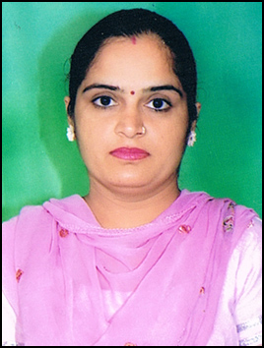 |  | GEN. | LIBRARIAN |  | ----- | ------- |  |  | ------ |  | M.LIB.  57% |  | LIBRARIAN | NO | NO | 8 YEAR | DEGREE COLLEGE 1 YEAR B.ED. COLL. 7 YEAR | 01/03/12 |  | 01/03/12
 | PRATIVA TIWARI 04.08.1986  34 YR . prativatiwariup@gmail.com |  | 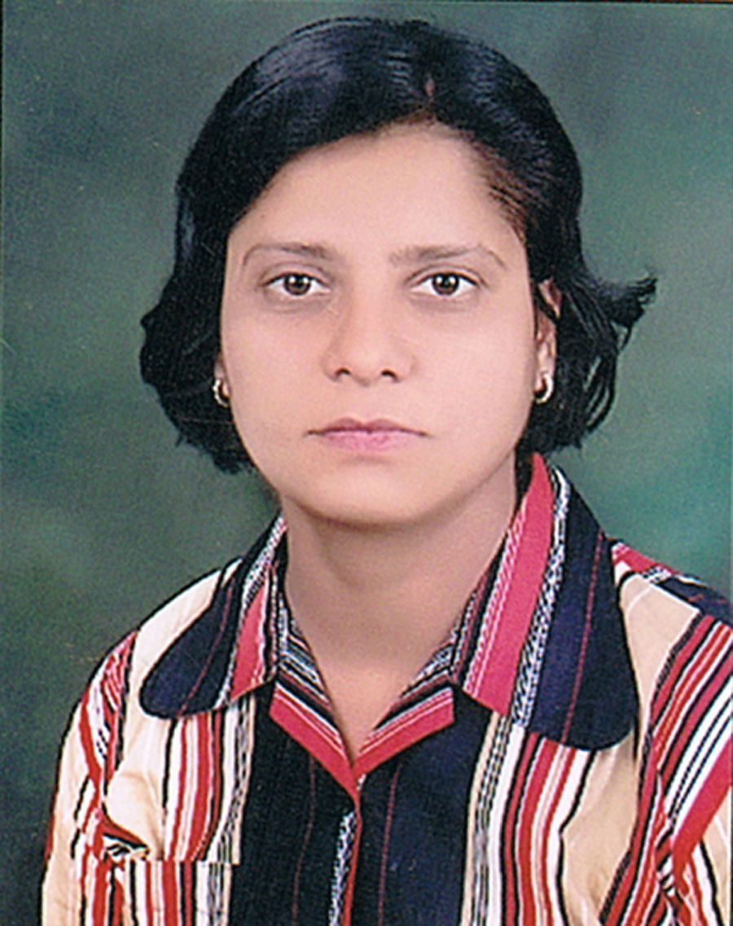 |  | GEN. | ASSISTANT PROFESSOR |  | YES 76% | YES 74% |  |  | -------- |  | M.A. POLITICAL SCIENCE 58.8% |  | TEACING OF SOCIAL STUDIES | YES | NO | 6 YEAR | B.ED. COLLEGE  6 YEAR | 20/04/18 |  | 20.04.18
 | RAJVEER KAUR 29.07.1991 30 YR  Lbabbi132@gmail.com |  | 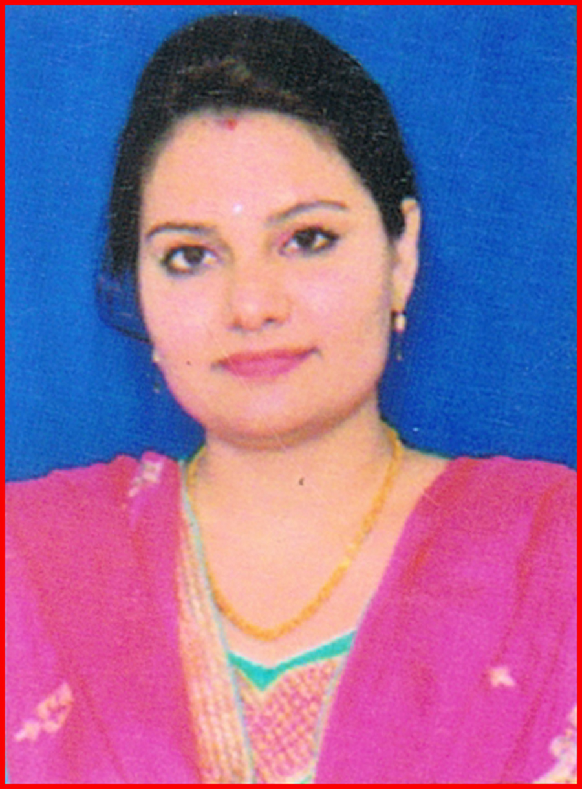 |  | GEN. | ASSISTANT PROFESSOR |  | YES 75% | YES 66.5% |  |  |  |  | M.A. PUNJABI 63.5% |  | TEACHING OF PUNJABI | NO | NO | 3 YEAR 6 MONTH | SCHOOL  1 YR.  B.ED. COLLEGE  2 YEAR 6 MONTH. | 16/11/17 |  | 16/11/17
 | RAJINDER KAUR 30.11.1986  34 YR. Bschahal580@gmail.com |  | 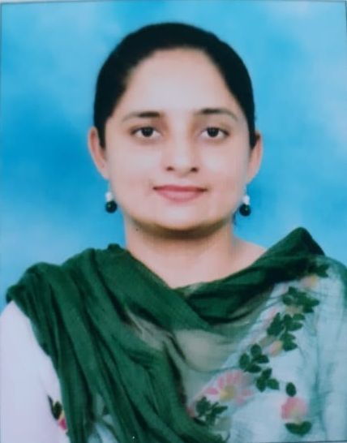 |  | GEN. | ASSISTANT PROFESSOR |  | Yes 77.7% | YES 75.5% |  |  | ------ |  | M.SC. (CHEMISTRY) 62% |  | TEACHING OF SCIENCE | NO | NO | 4 YEAR | B.ED. COLLEGE  4 YEAR | 16/11/17 |  | 16/11/17
 | SARBJEET KAUR 17.11.1981  39 YR.  Sarbjeetkaur98724@gmail.com |  | 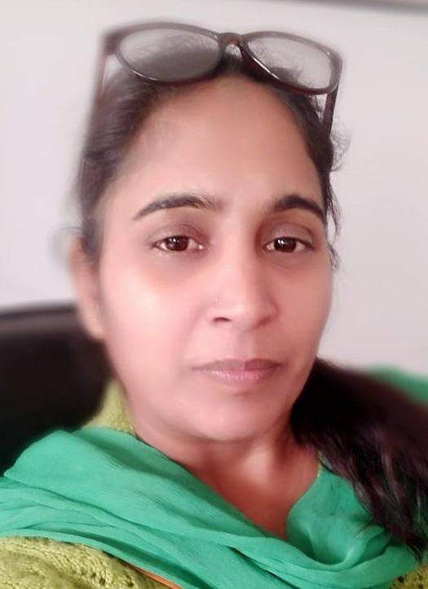 |  | BC | ASSISTANT PROFESSOR |  | YES 71.5% | NO |  |  | YES 59.67% |  | M.A. PUNJABI ( 55.38%) POLITICAL SCIENCE(58.25%) |  | TEACHING OF PUNJABI | NO | NO | 2 YEAR | B.ED. COLLEGE  2 YEAR | 20/04/18 |  | 20/04/18
 | GURWINDER KAUR  20.01.1988  32 YR.  gurwinderkaur@gmail.com |  | 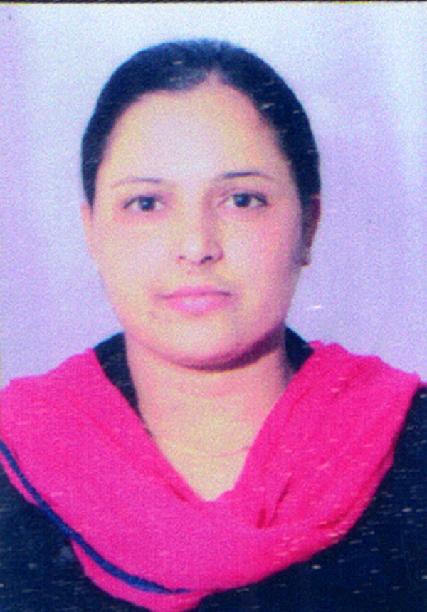 |  | GEN. | ASSISTANT PROFESSOR |  | YES 76.5% | YES 64.16% |  |  | ------ |  | M.A. POLITICAL 61% M.A. HISTORY 44.75% |  | TEACHING OF POLITICAL | NO | NO | 4 YEAR 6 MONTH | B.ED. COLL. 4 YEAR 6 MONTH | 16/07/18 |  | 16/07/18
 | SONIA 01.12.1986  34 YR  soniasharma@gmail.com |  |  |  | GEN. | ASSISTANT PROFESSOR |  | YES 72.08% | NO |  |  | YES 55.17% |  | M.C.A. 70% |  | TEACHING OF COMPUTER SCIENCE | NO | NO | 3 YEAR | B.ED. COLLEGE  3 YEAR | 19/09/17 |  | 19/09/17
 | HARDEEP KAUR  15.01.1994  24 YR.  Kaurdeep84276@gmail.com |  |  |  | GEN. | ASSISTANT PROFESSOR |  | YES 79.63 | YES 75% |  |  | ---- |  | M.A. ENGLISH  64% |  | TEACHING OF ENGLISH | NO | NO | ------ | ------ | 01/07/20 |  | 01/07/20
 | BANTI SINGH  08.01.1992  29 YR.  sbanti239@gmail.com |  | 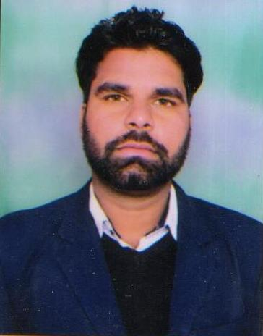 |  | SC | ASSISTANT PROFESSOR |  | M.P.E.D 76% | NO |  |  | --- |  | -------- |  | TEACHING OF PHYSICAL EDUCATION | NO | NO | ------- | ------ | 01/07/20 |  | 01/07/20
 | MOHINDERPAL  28.05.1966  55 YR.  mohinderpalmce2022@gmail.com |  | 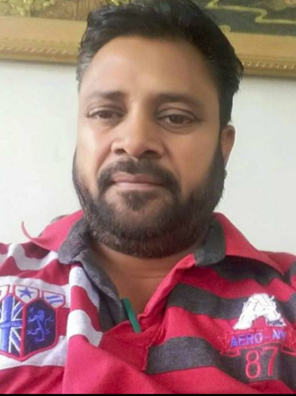 |  | GEN. | ASSISTANT PROFESSOR |  | NO | NO |  |  | --- |  | MASTER OF VISULE ARE  66% |  | TEACHING OF FINE ART | NO | NO | ------- | ------ | 01/12/21 |  | 01/12/21
 | JASWANT SINGH  24.05.1967  55 YR.  jaswantgrewal2022@gmail.com |  | 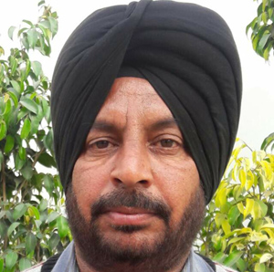 |  | GEN. | ASSISTANT PROFESSOR |  | NO | NO |  |  | --- |  | MASTER OF VISULE ARE  67% |  | TEACHING OF PERFORMING ART | NO | NO | ------- | ------ | 01/12/21 |  | 01/12/21
 | GAGANDEEP KAUR  26.11.1987  34 YR.  gagan26111987@gmail.com |  | 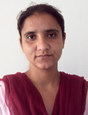 |  | GEN. | ASSISTANT PROFESSOR |  | YES  82% | NO |  |  | YES  55% |  | MASTER OF ART IN EDUCATION |  | TEACHING OF EDUCATION | NO | NO | ------- | ------ | 01/12/21 |  | 01/12/21
16. | KULWANT KAUR  28.12.1990  31 YR.  kulwantmcebirkalan@gmail.com |  | 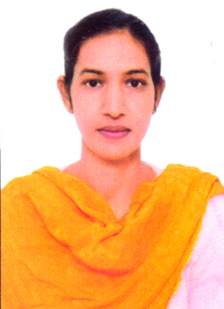 |  | GEN. | ASSISTANT PROFESSOR |  | YES  76% | YES  85% |  |  | -- |  | MASTER OF HISTORY |  | TEACHING OF HISTORY | NO | NO | ------- | ------ | 01/02/22 |  | 01/02/22

